El Paso Holocaust Museum and study Center

This is the art you will analyzed

This is outside of the living quarters for the Jews
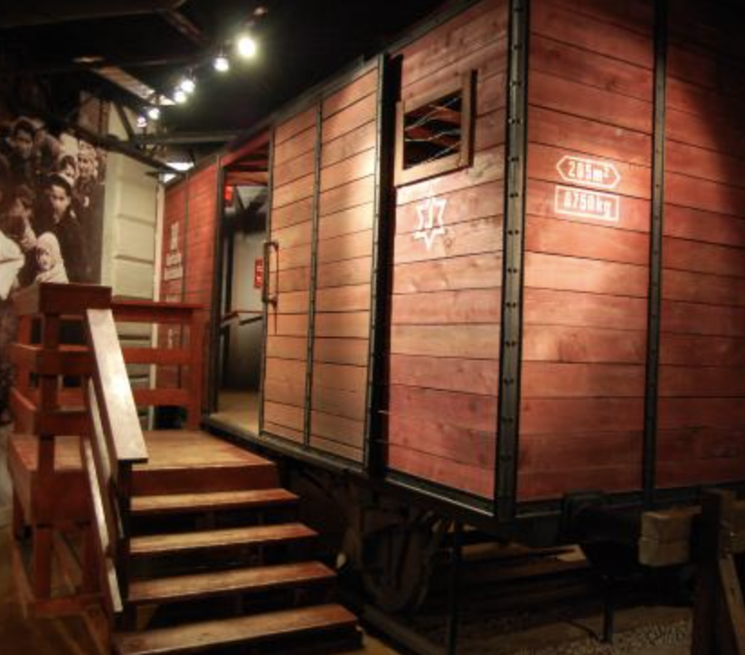

Inside the cabin
